- CLICK ‘Explore MAP’ and then zoom to general area.
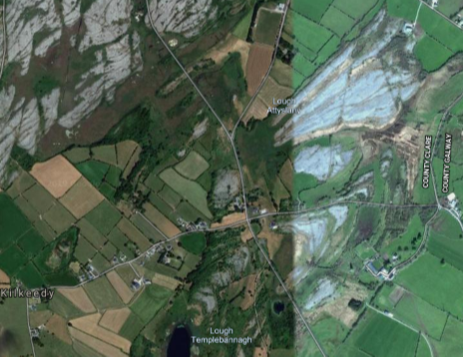
2 Zoom to where tree is planted.
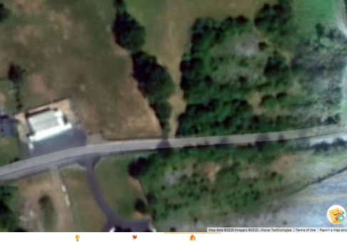

3 Select ‘MAP A TREE OR PLACE’
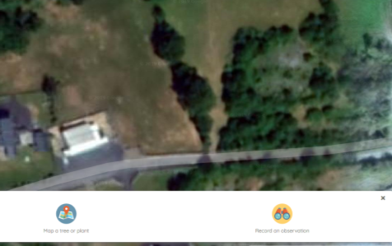
4 Mark your tree.
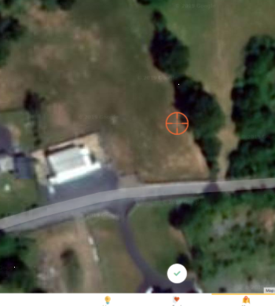

5 Select species in LATIN or Scot pine. Note there is step before this, but its not possible to screen capture it.
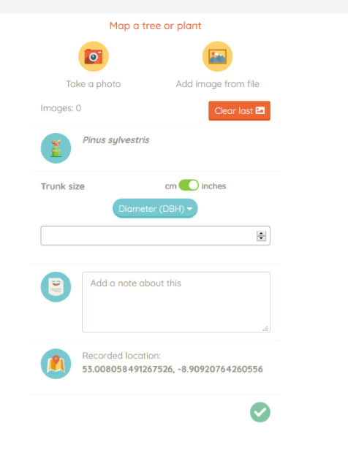

6 Click on coloured dot and click ‘SHOW MORE’ bottom RHS.
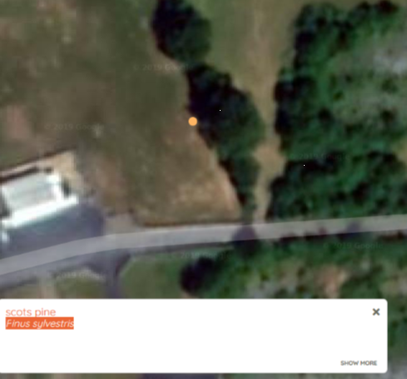

7 Click ‘EDIT DETAILS’
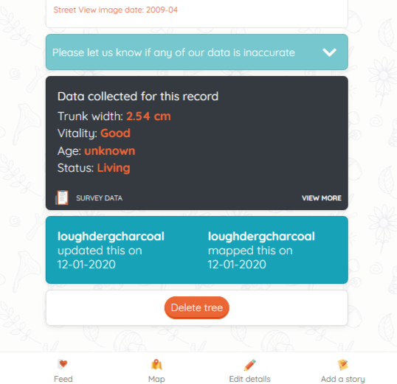

8 Scroll down and in 2 Add information box click on ADD NEW TAG insert #Burrenscotspine and click ‘SAVE’. Your tree is now saved and it along with other scots pine can be searched for at a later date.
